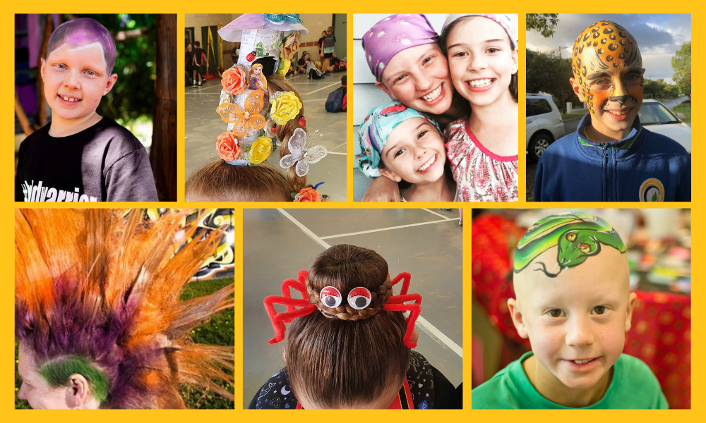
Crazy Hair Day
Name:
Date:
Alopecia Areata causes hair loss. It can affect anyone at any age, but is most common in children. We are hosting a Crazy Hair Day to help raise awareness and much-needed funds.
To take part, wear your craziest hairstyle and bring a gold coin donation.
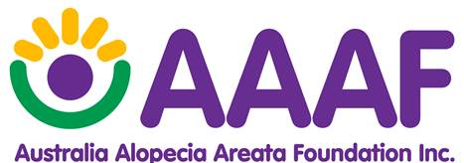
www.aaaf.org.au

